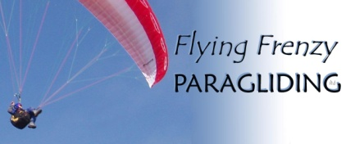 | Paragliding Taster Day  Voucher Booking Form  Please fill in your details and the details of the voucher’s recipient. Please fill in and email or print out and post this form. | 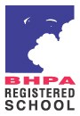

Your Name |  |  | E-mail
Address

Home Phone |  |  | Mobile
How did you
hear of us?
Their Name |  |  | E-mail
Address  (If not same as yours)  Don’t worry – we won’t contact them yet! | !
Home Phone |  |  | Mobile
Weight (Must be between 50 and 120kg - approx 7.5 and 19 stone)
Please give details of any physical or medical condition/s of the participant that
Flying Frenzy PARAGLIDING ltd staff need to be aware of to train as safely as possible
If you like we can include a short message on the voucher
Message;

From;
Your voucher; We can either print out and post your voucher or email it as a PDF document for you to print (full colour, double sided on card and folded to make an A5 leaflet). Please choose one option;
Please print for me and post / I’ll print it out thanks – please email it to me
The cost of the Taster Day is £160
(This includes the one day membership of the BHPA which costs £16 – the paperwork is done on the day.)

Please choose one option;
I have enclosed a cheque / have made a bank transfer (payment details below)

Payment details for bank transfer payments; Account number; 40133866 Sort code; 09 06 66
Please make cheques out to; Flying Frenzy PARAGLIDING ltd.

On receipt of payment we will send out a personalised voucher to your address (unless otherwise requested).

Terms and Conditions
- Taster Days are valid for a year from the date of booking. The valid till date is found on voucher.
- Refunds are not available. Failure to give us sufficient notice postponing the day’s tuition will result in the loss of that day’s fee.
- Minimum age for training is 14. If this voucher is for anyone under 18 years of age, a signed letter of consent is required from their parent or guardian and if they are also under 16 a parent or guardian must be present during training.
- If the Taster Day is not finished due to the student’s late arrival, their decision not to finish or their aptitude then no refunds will be given.
- All persons paragliding in the UK must be members of the BHPA.
- Paragliding is inherently hazardous. Accidents can happen even during training where every effort is made to reduce the risks.
- It is illegal to be in control of any aircraft, including a paraglider, when adversely affected by alcohol or drugs.
- Flying Frenzy PARAGLIDING ltd. reserve the right to terminate any instruction at any time if we consider a participant to be unfit or their conduct unsafe or inappropriate.
Declaration by purchaser of voucher;
- I have read, understand and accept the above Booking Terms and Conditions.
- I understand there is a risk of injury during paragliding training to the person for whom I am buying this voucher. It is my responsibility to ensure the recipient of this voucher is made aware of these risks.
Signature; | Date;

Flying Frenzy PARAGLIDING ltd
Manor Cottage, West Bexington
Dorchester . Dorset . DT2 9DF
andrewp@flyingfrenzy.com mobile; 0799 0505 725 office; 01308 898777 www.flyingfrenzy.com

